Table of Contents

* Project Overview ……………………………………………………………………………………………………………………………………………………………………. 2
* Elders of the Northern Bahamas……………………………………………………………………………………………………………………………………………. 3
* Main Project Outputs …………………………………………………………………………………………………………………………………………………………… 4
* Sponsorship Opportunity
  + Exposure for Sponsors ……………………………………………………………………………………………………………………………………………… 5
  + Sponsorship Packages ………………………………………………………………………………………………………………………………………………. 6
* Production Schedule ……………………………………………………………………………………………………………………………………………………………. 7
* Project Management ……………………………………………………………………………………………………………………………………………………………. 8
* Budget …………………………………………………………………………………………………………………………………………………………………………………. 9

40 Years 40 Voices

**Telling the history of the Bahamas through the stories of our elders**

Every Thursday, Bahamians skim through the pages of the obituary section of the daily newspapers to see ‘who dead’. Few stop to think how many libraries are lost with each new parting. The eldest members of our communities, in particular, contain a wealth of knowledge about who we are and how we came to be over the many past years of living memory. Unless their memories are recorded, much of our history will continue to be lost.

In celebration of the 40th anniversary of the Bahamas, the 40:40 Anniversary Project is a documentary initiative to record and preserve the history of the Bahamas through documenting the oral history of 40 living Bahamian elders over the age of 70.

**Project Overview**

The project will produce a series of **40 written biographical features**, **portraits albums**, and **mini video documentaries** on 40 Bahamian elders from across the Bahamas. The material will be published on a **commemorative website**, in a special edition **coffee table book** and broadcast on **local television stations**. The collection will be gifted to the **National Archives** and the **Oral** **&** **Public History Institute** of the University of The Bahamas and curated for display in a local **art gallery**.

Grant funding is needed to cover an estimated project cost of **$355,000** for the coordination and production of the 40 documentaries in all three mediums, and the distribution plan.

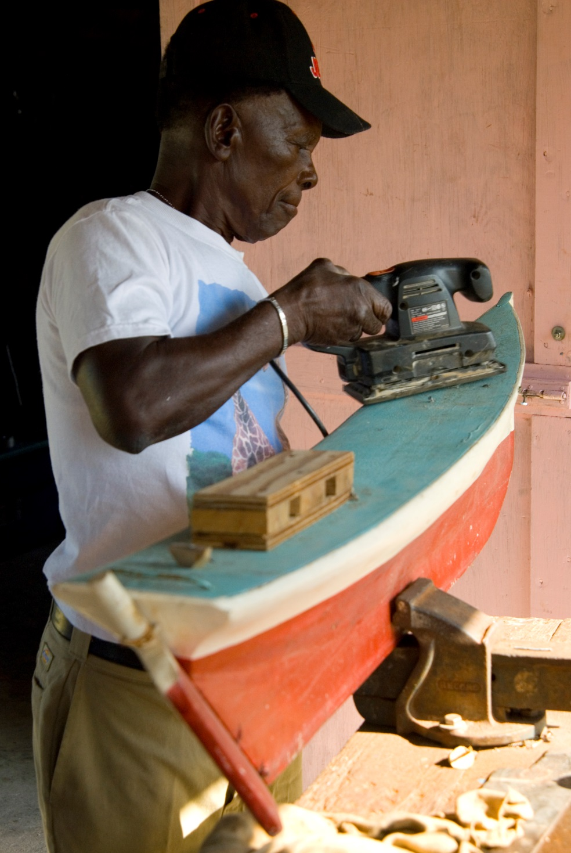.

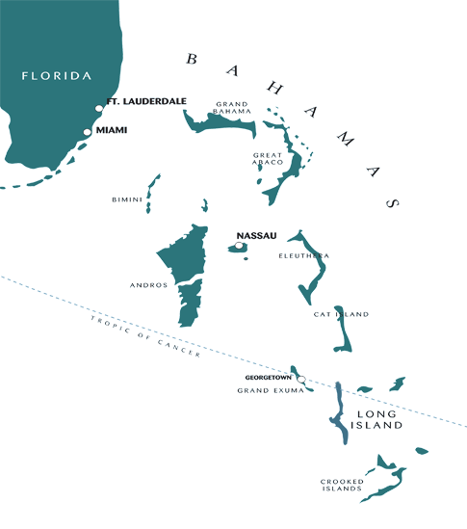

**Elders of The Northern Bahamas**

***Abaco, Grand Bahama, Berry Islands, Bimini***

The Northern Islands of the Bahamas have played an important role in Bahamian history. **Grand Bahama** has been a silent engine of economic development: from lumber to aragonite, the abundant natural resources have made Grand Bahama a hub of industrial activity. From Granma Smith in Eight Mile Rock to Sir Jack Hayward in Freeport, the elders contain much of the history.

**The Abacos** have produced some of the country’s best boat builders and sailors and continues to be a leading destination within the archipelago. The legacy of the original Loyalist settlers still gives the Abacos some of its character. From 80 year old Rev Morris Bain to boat builder Benjamin Pinder, the elders have much to share.

Just 40 miles off the Coast of Florida, **Bimini** gained its fame during the years of US Prohibition. Throughout its history, however, so many famous names have come to be associated with island: Ponce de Leon, Ernest Hemingway, Martin Luther King, Johnny Cash. The 40:40 Project will unearth the homegrown names and unsung stories.

The **Berry Islands**, a world renowned boating destination, has been a playground for the rich and famous through the years. Business woman Nora Turnquest, an elder well in her 90’s, is just one of the many elders who know the island’s interesting history.

**A total of 11 elders will be selected from the Northern Islands. The estimated project cost for the Northern Bahamas is $97,625.**

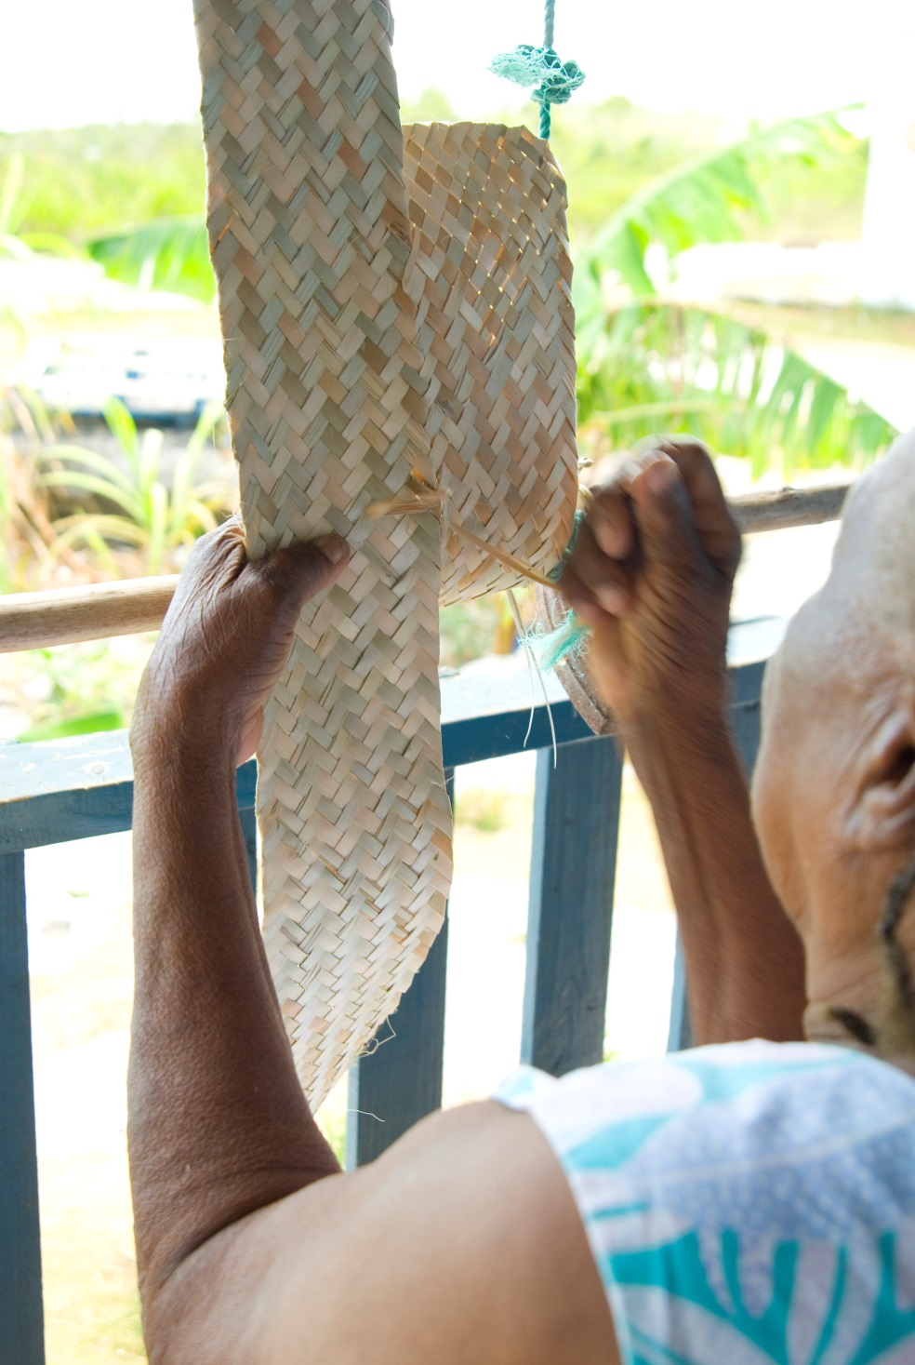Main Project Outputs

## Written Biographical Features

Oral histories are the living testimonies of people speaking about their own experiences. The biographical features will capture the oral histories of 40 Bahamian elders, shedding light on their private challenges, triumphs and milestones; the values and beliefs that shaped their reality; and the cultural practices that defined their Bahamian way of life. They will also shed light on the wider historical context those internal and external factors that shaped the life of each elder.

## Portrait Albums

The photographers will use documentary style photography to capture each elder as they recount their oral history. The photography will uniquely reflect the personality, mood and character of each elder. It will also capture their environment, providing historical and social context to the lives of each individual. The homes in which they live, the artifacts they live amongst, and the people or animals in their immediate environment will all be captured by the photographers lens.

## Mini Video Documentaries

The mini video documentaries are three to five minute shorts capturing a snapshot of each elder and recording the living voice and image of each elder. Each mini-documentary will be a standalone item, and weave together seamlessly as a series.

Sponsorship Opportunity

***Exposure across the length and breadth of the Bahamas***

Never before has a documentary project been undertaken to touch each and every region of the Bahamas. Sponsors of the 40:40 Anniversary Project will gain significant exposure by virtue of their involvement in the project. Not only will the individual families widely share the documentaries produced by this legacy project, but our proposed distribution plan will ensure the widest possible reach for the material. The archiving of the documentaries in the National Archives and the Institute of Public and Oral History at the University of the Bahamas will also ensure the documentaries have a place of prominence, particularly as there is a high degree of public interest in the 40th anniversary celebrations.

**Television Broadcast:** Each of the documentaries will be broadcast on national television. While individually, they will tell the story of each elder, collectively they will tell the story of the Bahamas. Each mini video documentary will significantly highlight an aspect the elder’s life that sheds light on a different dimension of Bahamian history and culture. They will stand alone, but also weave together like a tapestry when watched together.

**40:40 Website**: The website will ensure the documentaries receive the widest possible reach. It will serve as a resource centre for cultural and historical research. The content will be accessible for use in the school system, and it will help to restore a sense of respect and honour for our elders within the wider society. Various different placement positions will be integrated into the website to ensure a high level of visibility for sponsors.

**Coffee Table Book**: The portrait albums and the written biographies will be compiled into a commemorative coffee table book that will include placement opportunities for our sponsors. This book will be an invaluable independence keepsake.

**Gallery Exhibition**: Working with a prominent art gallery, the work will be curated into a public exhibit. The opening of the exhibit will serve as the launch event for the project once production has wrapped. Members of the National Independence Committee will attend the event as well as prominent invited guests, representing our sponsors and Bahamians in the cultural and historical community. The event and exhibition will be covered by national media.

**Sponsorship Packages**

**Platinum** **Sponsor: $35,000+ --------------------------------------------------------------------------------------------------------**

* Selection of two (2) elders
* Recognition in Title Credits and Closing Credits (Video Documentary)
* Full Page Tribute Ad in Coffee Table Book and Logo Placement on Sponsor Page
* Banner Ads on Home Page (Leaderboard Position) and Logo Placement on Sponsor Page (Website)

**Gold Sponsor: $20,000+ ------------------------------------------------------------------------------------------------------------**

* Selection of one (1) elder
* Recognition in Title Credits and Closing Credits (Video Documentary)
* Half Page Tribute Ad in Coffee Table Book and Logo Placement on Sponsor Page
* Banner Ads on Home Page (Column Position) and Logo Placement on Sponsor Page (Website)

**Silver Sponsor: $5,000+ ------------------------------------------------------------------------------------------------------------**

* Recognition in Closing Credits (Video Documentary)
* Quarter Page Tribute Ad in Coffee Table Book and Logo Placement on Sponsor Page
* Banner Ad on Regional Group Page and Logo Placement on Sponsor Page (Website)

**Bronze Sponsor: 0-$4,999 ---------------------------------------------------------------------------------------------------------**

* Recognition in Closing Credits (Video Documentary)
* Logo Placement on Sponsor Page in Coffee Table Book
* Logo Placement on Sponsor Page (Website)

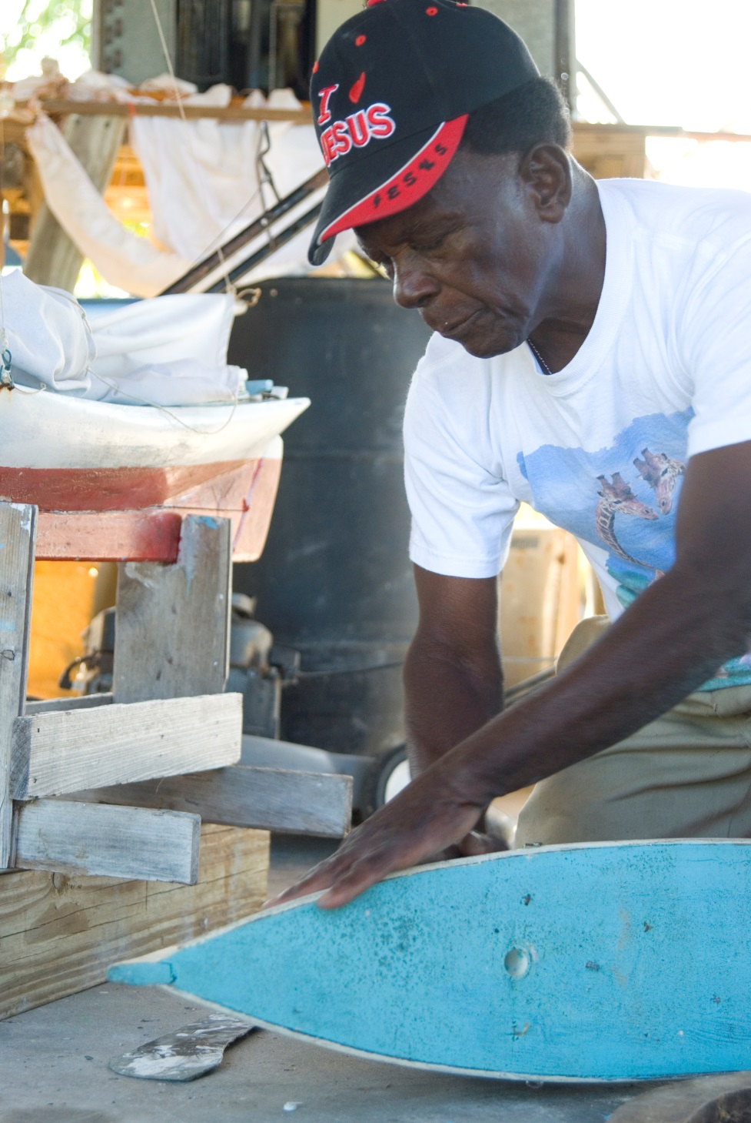Production Schedule

The total project timeline is estimated at 8-months.

**Selection of Elders**: 40 elders of 70 years or more will be selected from across the Bahamas: 11 elders from the Northern region; 12 elders from the Central region; 11 elders from the south eastern region and 6 elders from the southern region. Some of the preliminary research and pre-interviewing will take place in this stage.

**Planning and Coordination**: Interview will be scheduled with the elders and all of the relevant permissions will be secured. The production team will be assigned and scheduled for work.

**Production**: The production team will travel to the various sites to conduct interviews with the elders for the written biographies, and capture footage for the documentaries.

**Post-Production**: During post-production the documentaries will be edited and mastered, and the website and coffee table book will be created.

**Distribution and Promotion:** The launch and public exhibition will be planned and staged, and the television series will be aired.

Project Implementation

The 40:40 Anniversary Project is the creation of journalist and entrepreneur Noelle Nicolls, founder of Q-Tech Communications. Q-Tech Communications, a registered business in Nassau, Bahamas is the implementing agency.

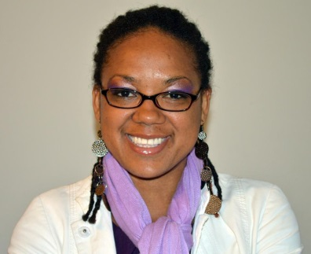**Project Manager: Noelle Nicolls**

Noelle Nicolls is a Bahamian journalist and entrepreneur. She heads the features department at The Tribune newspaper, the leading daily in Nassau, Bahamas. Her investigative talent, keen insight and engaging writing style have propelled her to the forefront of the profession. Her articles are regularly displayed on the front pages of the newspaper, and in the paper’s signature column, Insight.

Noelle is also the founder and chief executive officer of Q-Tech

Communications, a boutique consulting firm with more than five years experience in media production, communication consulting, publishing and project management.

**Project Officer: Nadine Thomas-Brown**

Nadine Thomas-Brown is a talented journalist with deep roots in the world of entertainment. She brings culture, creativity and a versatile style to her work in media. She is the founder and director of Roots & Culture TV, a television series for artistes to showcase their talent. She was once an educator, but now uses her Express Yourself, once the longest running open mic show in the Bahamas, and.

Project Cost

The overall cost the project is **$241,000**. The budget covers all costs associated with coordination and production of the documentaries.

“Much of the history of the Bahamas is still unwritten, because many stories are still contained *in* the memory of our elders, the tradition bearers and griots. While most elders are eager to share their stories with grandchildren and immediate family, in today’s society many of them do not see their stories as relevant or valuable within a wider national narrative. In reality, each and every story represents a piece of the national tapestry.”